**ESPM Dragon Blood Reference Application Design Document**

Contents

1. Architecture 3

2. Data Model 5

2.1 Product Service 5

2.2 Customer Service 7

2.3 Sales Service 8

3. Service Document 9

# Architecture

The below block diagram shows the architecture of the ESPM application

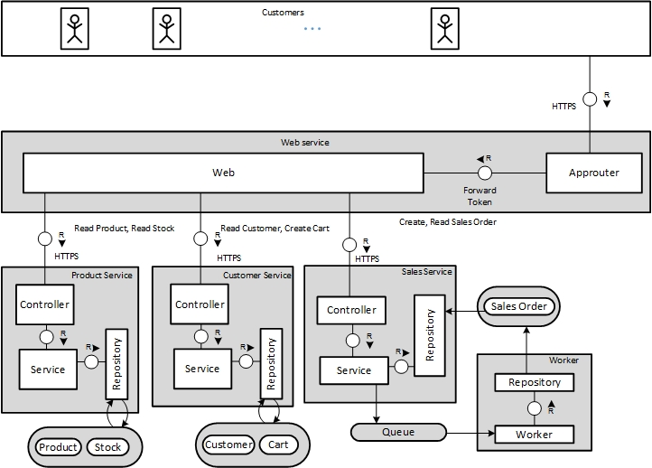

The design pattern implementation scheme is shown in the diagram below

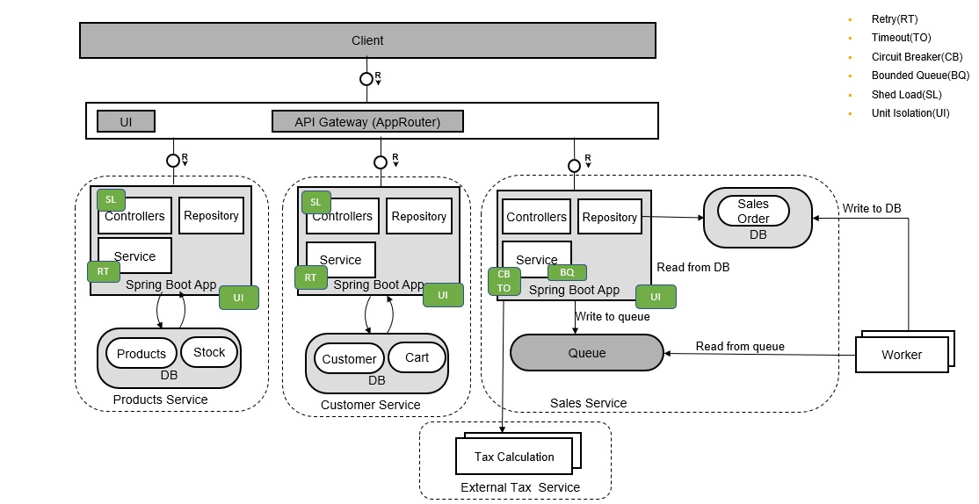

# Data Model

## 2.1 Product Service

**Products**

|  |  |  |  |  |  |
| --- | --- | --- | --- | --- | --- |
| **Column Name** | **Database**  **Data Type** | **Java Data Type** | **Length** | **Constraints** | **Remarks** |
| PRODUCT_ID | VARCHAR | String | 10 | PKey |  |
| NAME | VARCHAR | String | 255 |  | Name of the Product |
| SHORT_DESCRIPTION | VARCHAR | String | 255 |  |  |
| CATEGORY | VARCHAR | String | 40 |  |  |
| WEIGHT | NUMERIC | BigDecimal | precision = 13, scale = 3 |  |  |
| WEIGHT_UNIT | VARCHAR | String | 3 |  |  |
| PRICE | NUMERIC | BigDecimal | precision = 23, scale = 3 |  |  |
| CURRENCY_CODE | VARCHAR | String | 5 |  |  |
| DIMENSION_WIDTH | NUMERIC | BigDecimal | precision = 13, scale = 4 |  |  |
| DIMENSION_DEPTH | NUMERIC | BigDecimal | precision = 13, scale = 4 |  |  |
| DIMENSION_HEIGHT | NUMERIC | BigDecimal | precision = 13, scale = 4 |  |  |
| DIMENSION_UNIT | VARCHAR | String | 3 |  |  |
| PICTURE_URL | VARACHAR | String | 255 |  |  |

**Stock**

|  |  |  |  |  |  |
| --- | --- | --- | --- | --- | --- |
| **Column Name** | **Database Data Type** | **Java Data Type** | **Length** | **Constraints** | **Remarks** |
| PRODUCT_ID | VARCHAR | String | 10 | PKey |  |
| QUANTITY | NUMERIC | BigDecimal | precision = 13, scale = 3 |  |  |

## 2.2 Customer Service

**Customer**

|  |  |  |  |  |  |
| --- | --- | --- | --- | --- | --- |
| **Column Name** | **Database**  **Data Type** | **Java Data Type** | **Length** | **Constraints** | **Remarks** |
| CUSTOMER_ID | VARCHAR | String | 10 | PKey |  |
| EMAIL_ADDRESS | VARCHAR | String | 255 | Unique |  |
| PHONE_NUMBER | VARCHAR | String | 30 |  |  |
| FIRST_NAME | VARCHAR | String | 40 |  |  |
| LAST_NAME | VARCHAR | String | 40 |  |  |
| DATE_OF_BIRTH | VARCHAR | String | 255 | Not Null |  |
| CITY | VARCHAR | String | 40 |  |  |
| POSTAL_CODE | VARCHAR | String | 10 |  |  |
| STREET | VARACHAR | String | 60 |  |  |
| HOUSE_NUMBER | VARCHAR | String | 10 |  |  |
| COUNTRY | VARCHAR | String | 3 |  |  |

**Cart**

|  |  |  |  |  |  |
| --- | --- | --- | --- | --- | --- |
| **Column Name** | **Database**  **Data Type** | **Java Data Type** | **Length** | **Constraints** | **Remarks** |
| ITEM_ID | VARCHAR | String | 10 | PKey |  |
| CUSTOMER_ID | VARCHAR | String | 10 |  |  |
| PRODUCT_ID | VARCHAR | String | 10 |  |  |
| QUANTITY | NUMERIC | BigDecimal | precision = 13, scale = 3 |  |  |
| CHECK_OUT_STATUS | BOOLEAN | Boolean |  |  | Checked out Y/N |

## 2.3 Sales Service

**Sales Order**

|  |  |  |  |  |  |
| --- | --- | --- | --- | --- | --- |
| **Column Name** | **Database**  **Data Type** | **Java Data Type** | **Length** | **Constraints** | **Remarks** |
| SALES_ORDER_ID | VARCHAR | String | 10 | PKey |  |
| CUSTOMER_EMAIL | VARCHAR | String | 255 |  |  |
| CURRENCY_CODE | VARCHAR | String | 5 |  |  |
| GROSS_AMOUNT | NUMERIC | BigDecimal | precision = 15, scale = 3 |  |  |
| NET_AMOUNT | NUMERIC | BigDecimal | precision = 15, scale = 3 |  |  |
| TAX_AMOUNT | NUMERIC | BigDecimal | precision = 15, scale = 3 |  |  |
| LIFE_CYCLE_STATUS | VARCHAR | String | 1 | Not Null | N - New  I – In Progress  X - Cancelled |
| LIFE_CYCLE_STATUS_NAME | VARCHAR | String | 255 |  |  |
| CREATED_AT | VARCHAR | String | 255 |  |  |
| DELIVERY DATE | VARCHAR | String | 255 |  |  |
| PRODUCT_ID | VARCHAR | String | 10 |  |  |
| QUANTITY | NUMERIC | Big Decimal | precision = 13, scale = 3 |  |  |
| QUANTITY_UNIT | VARCHAR | String | 3 |  |  |

LIFE_CYCLE_STATUS column can have values

* New - N
* In Progress - I
* Cancelled - X

When a new sales order is created the status in N (New). If the Stock is available, its changed to In Progress. If no stock is available the status us changed to X (Cancelled)

# Service Document

**Service URL**

/customer.svc/api/v1/customers/

/customer.svc/api/v1/ customers /{customerId}carts/

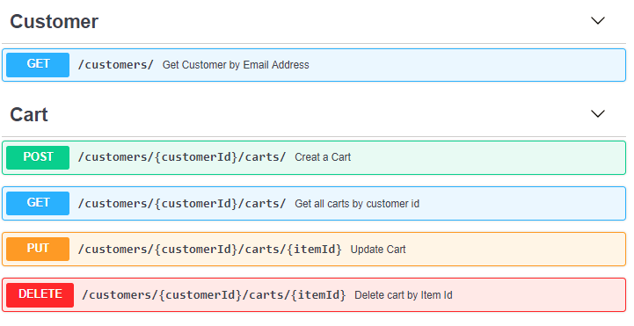

**Service URL**

/product.svc/api/v1/products/

/product.svc/api/v1/stocks/

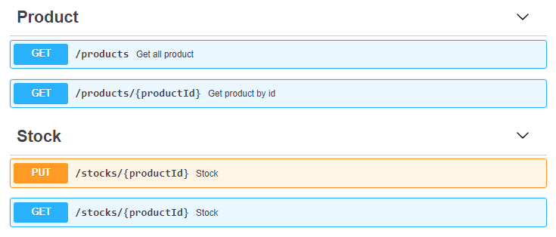

**Service URL**

/sale.svc/api/v1/sales

